**ASSIGNMENT 5.2:**

**COMMANDS:**



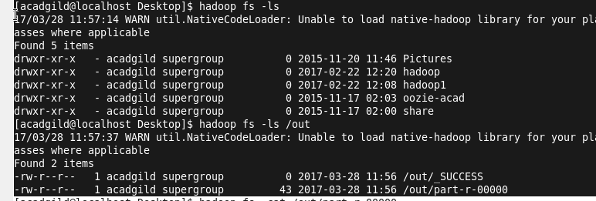

**MAPPER:**

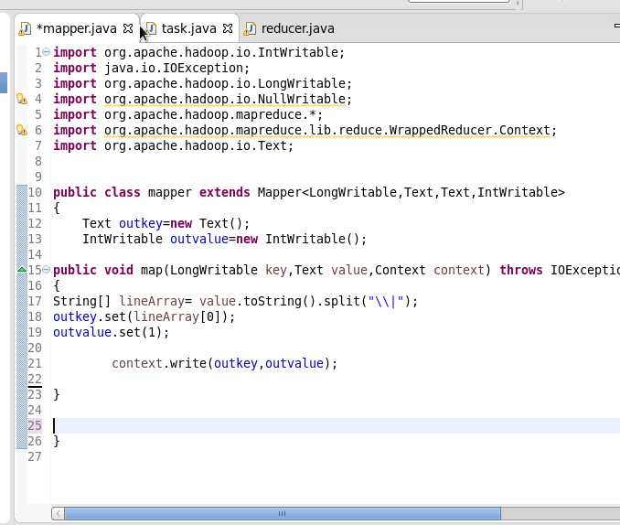

**DRIVER:**

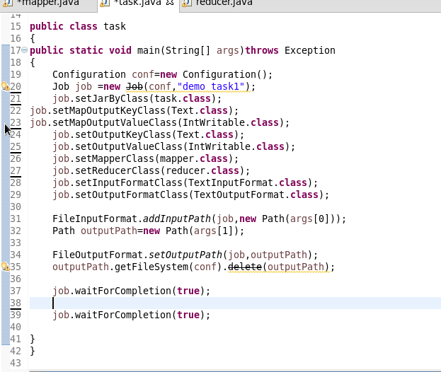

**REDUCER:**

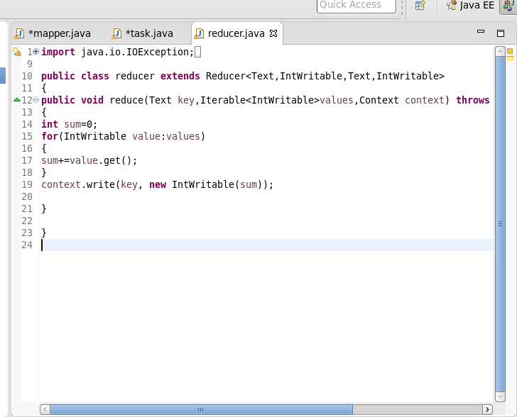

**OUTPUT:**

